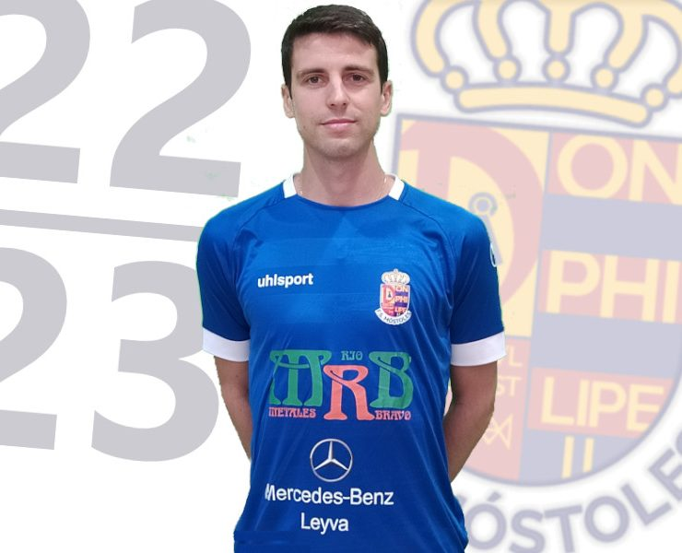D. ASENSIO

Surnames: Asensio Palacios

Name: David

Date of Birth: 25/01/1991

Place of Birth: Madrid (Spain)

Nationality: Spanish

Marital Status: Swinger

Lenguages: Spanish: Mother Tonge

English: Medium Level



SPORT INFORMATION

Demarcation: Flank - Defender

Dominant leg: Left

Team: Ciudad de Móstoles

Current Club: FS Talavera

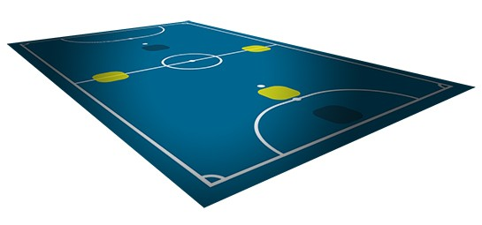

SPORT CARRER

|  |  |  |
| --- | --- | --- |
| Club | Category | Season |
| Ciudad de Móstoles | 2 Division/2 Division B | 2021/Actually |
| FS Talavera | 2 Division | 2018/2021 |
| Pesaro Calcio | 1 Division. Italy | 2017 |
| P. Romero Cartagena | 1 Division | 2016/2017 |
| Peñíscola Rehab Medic | 1 Division | 2013/2016 |
| Arenas Galdar G. C. | 1 Division | 2012-2013 |
| FC Barcelona B | 2 Division | 2010/2012 |
| Boadilla Las Rozas | U-18 | 2007/2010 |
| Boadilla Las Rozas | U-14, U-16 | 2005/2007 |



SPORT ACHIEVEMENTS

⚫ Sub 21 Internacional Spain Team

⚫ Spain Champions to Club

⚫ Spain Champions to Selection

