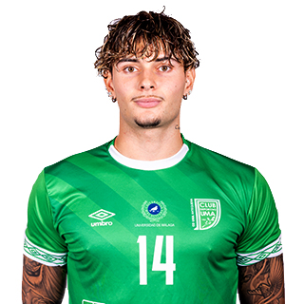DANIEL

Surnames: Fernández García

Name: Daniel

Date of Birth: 08/03/2001

Place of Birth: Alcalá de Henares

Nationality: Spanish

Lenguages: Spanish: Mother Tonge

English: Medium Level

Catalan: Mother Tonge



SPORT INFORMATION

Demarcation: Flank/defender

Dominant leg: Right

Current Club: UMA Antequera



SPORT CARRER

|  |  |  |
| --- | --- | --- |
| Club | Category | Season |
| UMA Antequera | First Division | 2022/Actually |
| Barça FS | U-16/Second Division | 2016/2022 |
| Rivas Futsal | U-16 | 2015/2016 |
| Rivas 95 | U-14 | 2014/2015 |
|  |  |  |



SPORT WINNERS

* World U-21 Champion

